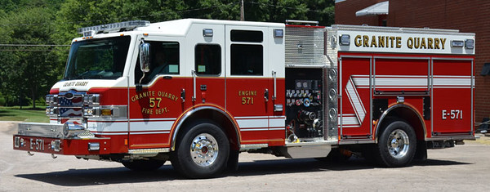
2018 Granite Quarry Fire Department
Open House / Community Meet & Greet
October 13th, 2018
10:00am – 3:00pm
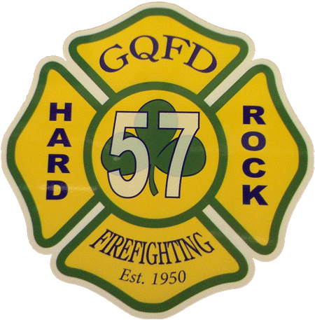
Meet your local firefighters!
Tour the firehouse!
Meet Sparky the Fire Dog!
See the fire engines and equipment!
Fire & Safety Education materials!
Visit various community organizations!

Refreshments provided by the following:
Call
704-279-5597
For More Info!
Slice of Heaven Pizza

Granite Quarry Fire Department

