Everyone needs help sometimes. Let’s be the community that cares enough to make a difference!

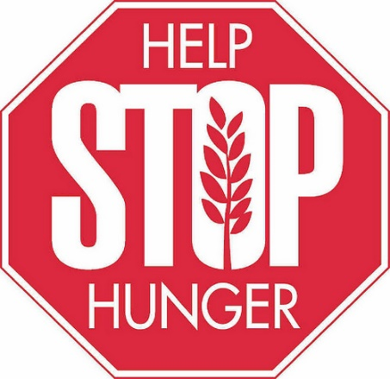
This Photo by Unknown Author is licensed under CC BY-NC
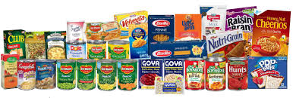
The Town of Granite Quarry is kicking off its Food Drive on September 1st and will be going strong through December. We will be collecting all non-perishable foods and taking them to local shelters and food banks. All donations with stay in our area.
In addition to food, please consider donating other necessities such as blankets, toiletries, laundry supplies, socks, and baby supplies such as diapers and wipes.
YOU CAN MAKE A DIFFERENCE!
Convenient drop off at Granite Quarry Town Hall
143 N. Salisbury Ave, Granite Quarry

